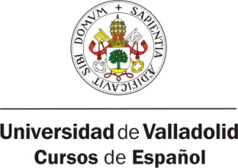 | Centro de Idiomas de la Universidad de Valladolid
 | Cursos de Español para Extranjeros
 | Paseo de Belén 13, Campus Miguel Delibes, 47011 Valladolid, Spain
 | Tel: (+34) 983 18 46 67 – Fax: (+34) 983 18 46 71
 | www.spanishinvalladolid.com

STAFF WEEK REGISTRATION FORM

First name
Last name
Nationality |  |  |  |  | Passport Number or National ID
Date of birth
Home address
City |  |  |  |  |  |  | Country
Mobil Phone number
E-Mail
Home institution
Department work area
Position
Job description. What are your main responsibilities at your home institution?
Special field of interest
Level of Spanish Language Competence
A2 |  |  | B1 |  |  | B2 |  |  | C1
Other spoken languages
Erasmus code

Send this registration form to: isabel@funge.uva.es

Data protection
According to the provisions of Law 15/1999 of 13 December Protection of Personal Data, we inform you that the information you provide will be incorporated into files under the ownership and responsibility of the General Foundation of the University of Valladolid in Plaza de Santa Cruz, 5 , 47002 Valladolid . The user is solely responsible for the accuracy and correctness of the data sent, General Foundation of the University of Valladolid declines any responsibility for their lack of veracity or correction. The purpose of the file is to facilitate the management and administration for the provision of our services, answer questions and address the suggestions that arise through this medium, all in order to expand and improve the services offered.

